# **Gigs N’ Chill**

# **User's Manual**

## **CSCI-P465/565 (Software Engineering I)**

## **Project Team**

**Deepan Elangovan**

**Harsha Valiveti**

**Jackie Drs**

**Andrew Gotts**

### 

## 1. Product Overview

Provide a brief (1-2 paragraph) description of the software product and its capabilities.

Gigs N Chill is a website to show events such as Movies, Plays, Music Performances, etc to encourage the local events. The events on the site are created through the host end of the product. On the hosts profile page, they can view the events that they are hosting, past events they have hosted, view the users registered for the events, and cancel an event. On the user end they can search through the events based on filters such as what type of event, the location of the event and whether it is free. They can book an event, like an event or share the event through email. Both the host and the user can chat within the site to others that have signed up. On the user's profile page, they can view their current and past events that are pinned into their Calendar, ability to cancel the reservation and update their profile.

## 2. System Requirements

Detail the minimum system requirements to operate your product. If you are using a support software package, be sure the system requirements you list are consistent with the requirements to use the support package.  
  
Updated Web Browser, JavaScript, NodeJS, React Framework, Python, Django, MySQL, Heroku, AWS.

## 3. Product Installation

Provide a sequence of steps that details how to install the product. Assume that the software product has just been handed to you on the media you provide. Detail exactly how to install the software onto a system. If your software depends on the presence of other software support packages, detail how to install those packages or provide a link to a website that provides this detail (for example, if your software requires Python to run, provide a link to the Python installation web site).

The backend and frontend require different steps to install and get working. Both sections are outlined below:

Step 1: Clone our code repository

* Navigate to <https://github.iu.edu/deelango/GigsNChill>
* Clone the repository to your local machine

Step 2: Install necessary packages

Frontend:

* Download the latest React JS framework
  + <https://reactjs.org/>
* After installing the Framework, installing the necessary packages that support the development
  + npm I -- that installs all of the packages into local.
* Then, open a working terminal matching with the path of Frontend directory, start the environment to have the application up and running
  + npm start
* Then Signup for the role you are looking for, start exploring the local events.

Backend:

* Download the latest version of Python
  + <https://www.python.org/downloads/>
* Once downloaded run the executable and install python
* Navigate to the GitHub repository
* Open a terminal, command prompt, or python shell
* Run the following command to install all the necessary Python Libraries
  + pip install -r requirements.txt

## 4. Product Operation

Details in this section how to use your product. The format for this section is at your discretion. Assume that the software has been successfully installed. Guide the user through program start-up, describe the various modes of operation or sequence of steps to perform actions within your tool, and describe how to close down the program. Include screen shots, and detailed descriptions of the necessary steps to use your system. Assume that the audience for this artifact is not a software engineer.

Program Start Up:

* Everything is hosted in the cloud ( Heroku, AWS, and Firebase )
* Simply navigate to https://gigsnchill-events.web.app/

To build locally:

* Ensure you are the root of the cloned github repository
* Start the backend server: python manage.py runserver
* In a separate terminal navigate to the /frontend directory: cd frontend
* Start the frontend server: npm start

Once starting the application, the user will be taken to a screen where they are directed to either sign up or login.  
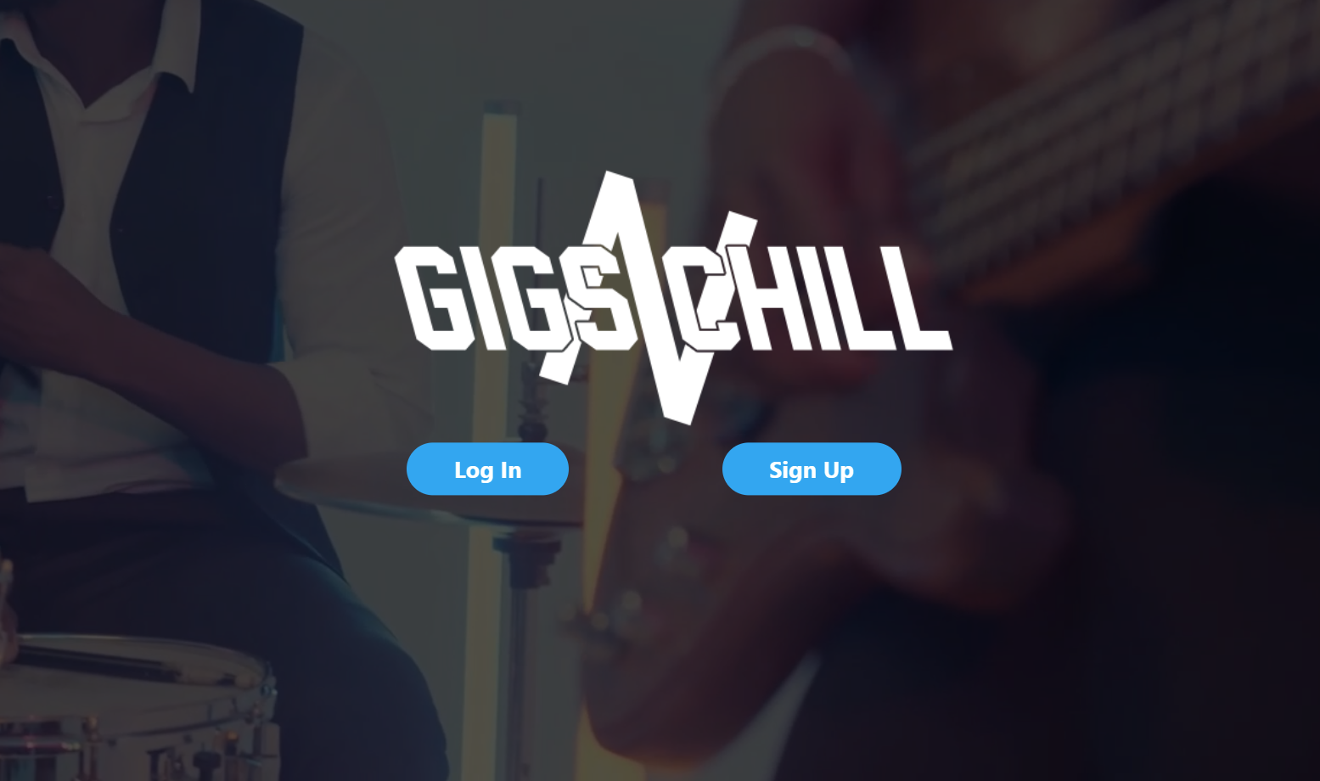

Once signing up or logging in they will be taken to the home page of the site. From this page they will be able to browse through the events either through preset filters on the left or through a search engine at the top. Once they find an event, they can click on it.

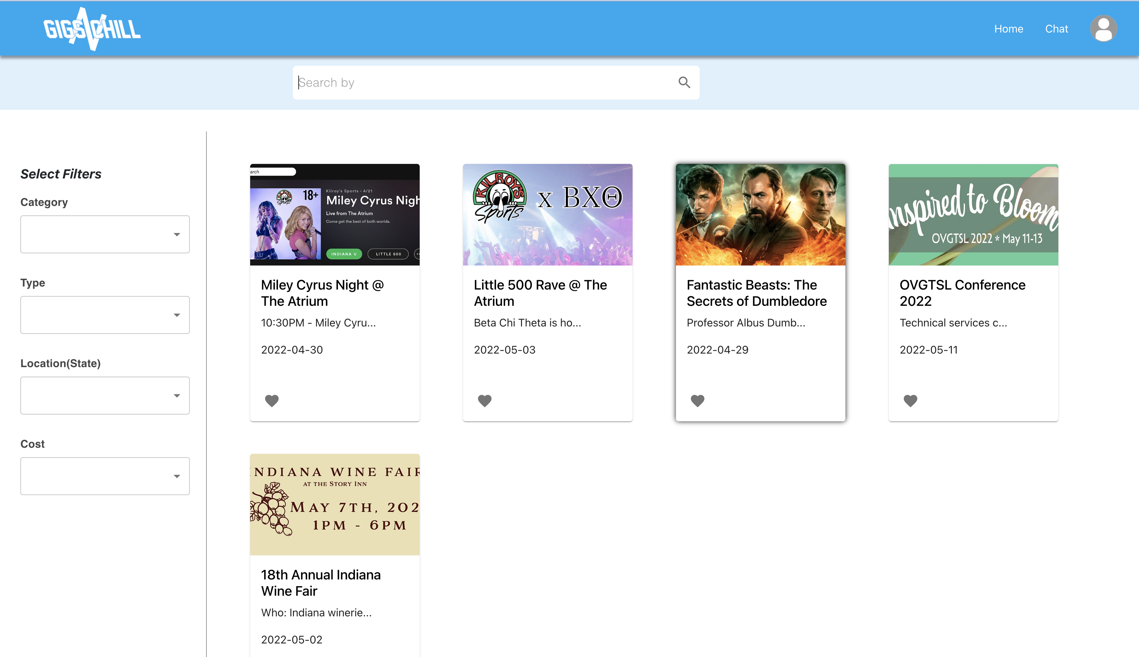

After clicking on an event, they will be taken to a page like the one below. From there they can see details about the event, decide how many tickets they would like to book for the event, and book the event.

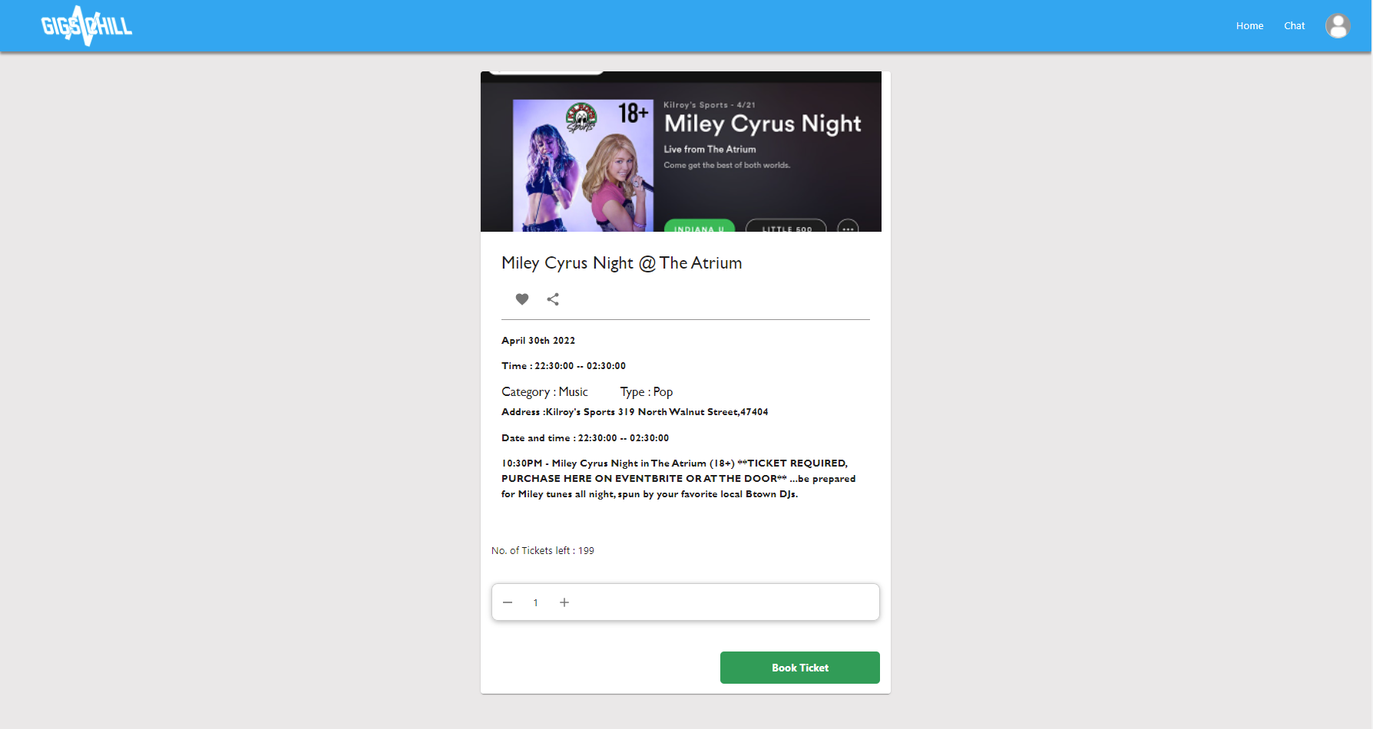

From the search bar at the top if they click on the profile icon there is a drop down where they can choose profile, like, or logout. Below is a picture of the user's profile page. Here they can change their information displayed on the top left. They can see a calendar with their events. Then to the right if the page they can see their upcoming events, past events, and canceled events. The host view is similar but shows the events that the host is hosting. They can click on any of the events shown.

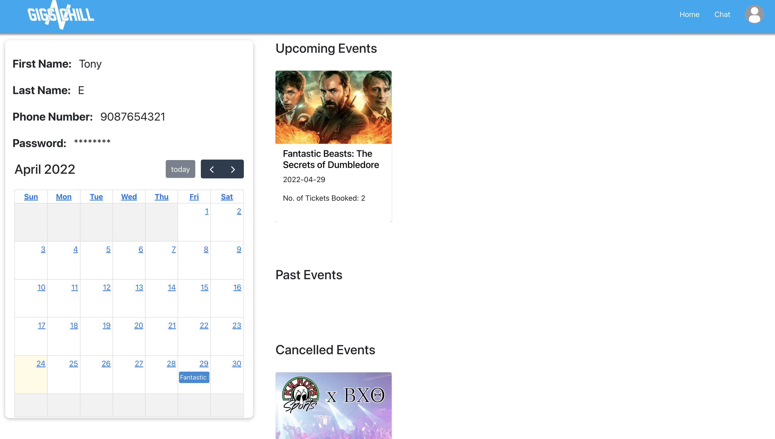

Here is what is shown when an event from the profile page is clicked on. It shows details pertaining to the event, the number of tickets that were booked and the option to cancel it. The host view is similar, but will also show the host the users that ae register for the event.

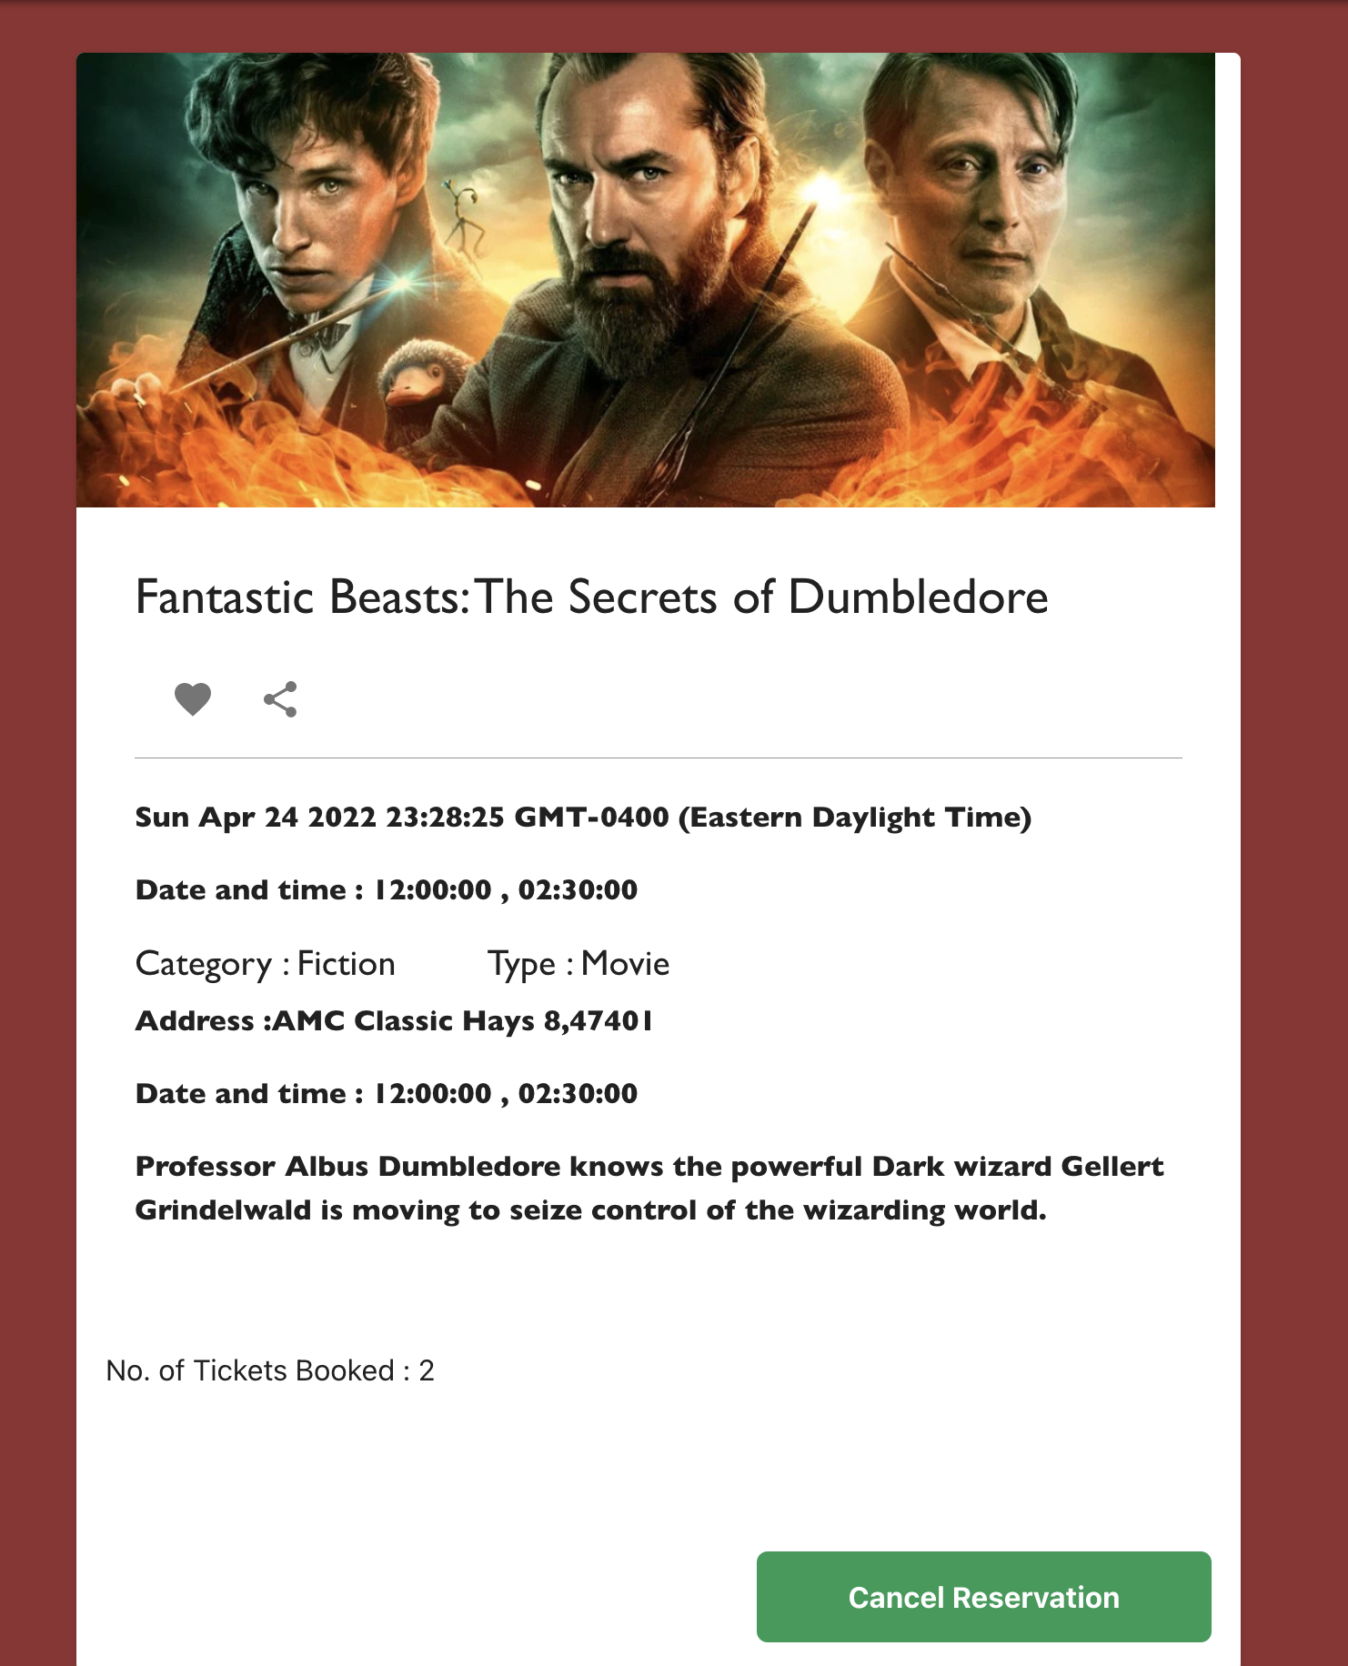

A page to view the Bookmarks of a user that displays the Bookmarked Events and has the ability to Unbookmark an event that updates with the DataBase.

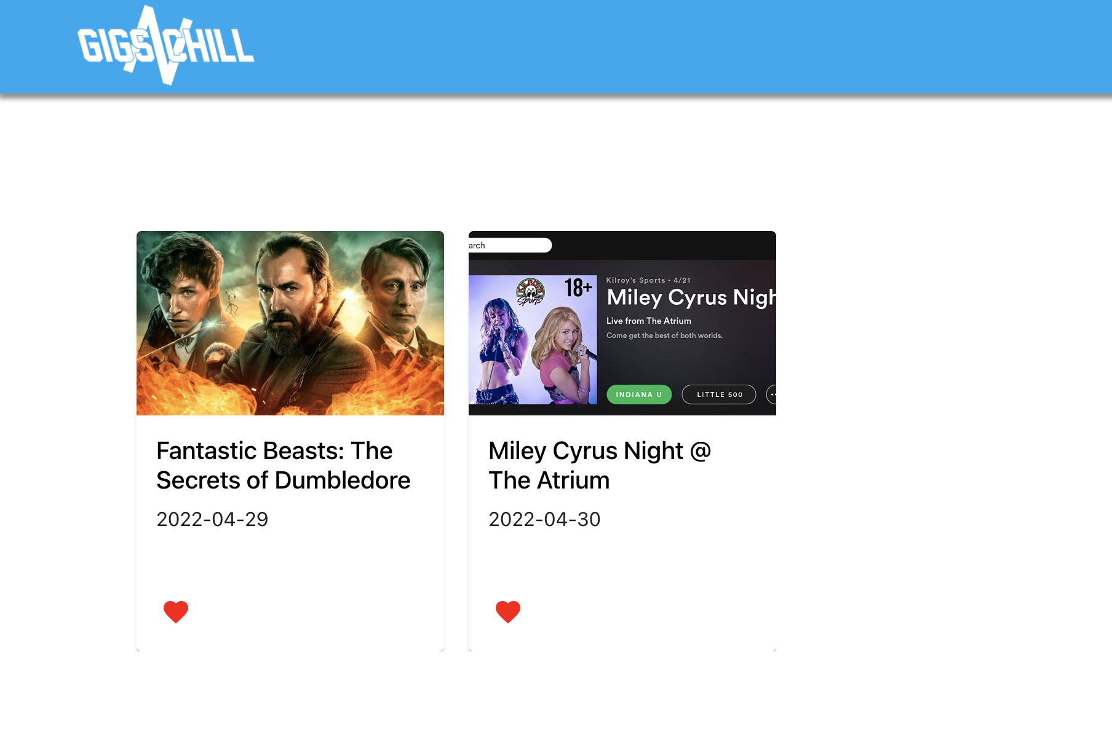

This is the chat page which can be navigated to by the bar at the top of the page. From the chat page the users can communicate with others that an account.

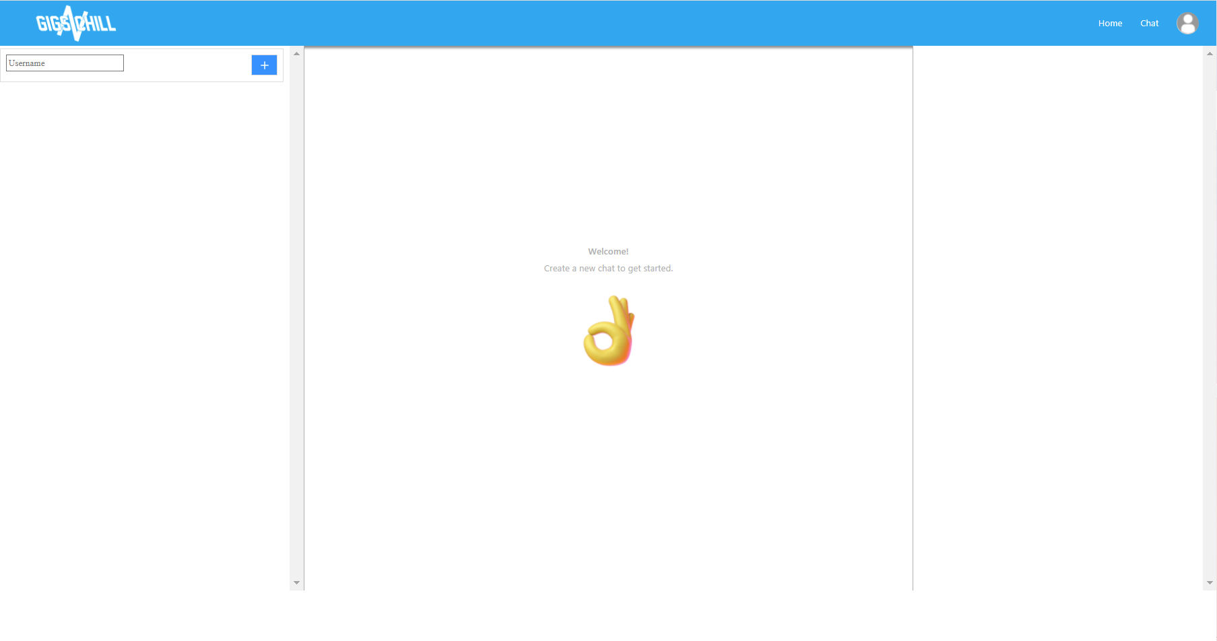

At the top of the host page there is an option to host an event. Once clicked on they will be directed to the page below. Here they fill in information prompted for the event and then at the bottom they can push the event to the public.

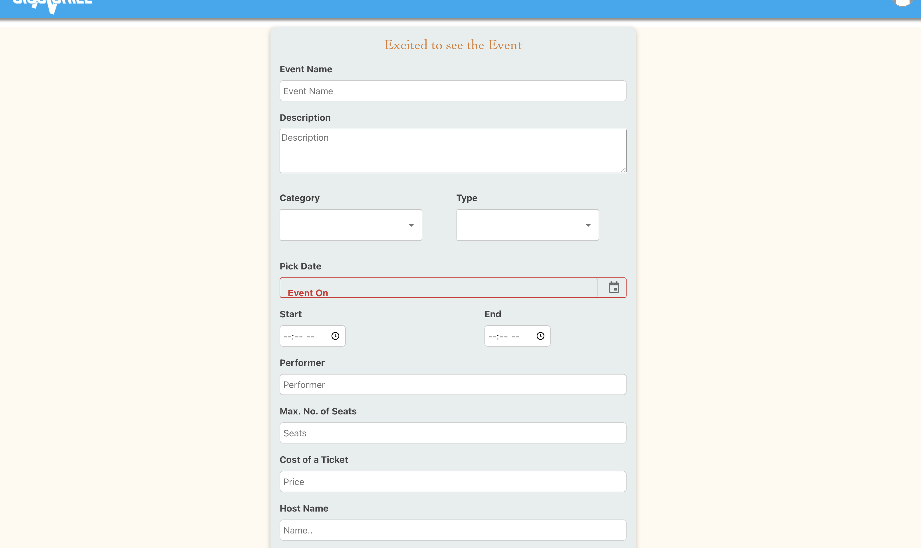

## 5. Known Defects

Describe any known operational defects associated with the product.

* Does not support Two Factor Authentication
* Unable to initiate payment

## Revision History

|  |  |  |
| --- | --- | --- |
| **Revision** | **Date** | **Change Description** |
| Initial Creation | 4/24/22 | Fill out the document |
|  |  |  |
|  |  |  |
|  |  |  |
|  |  |  |
|  |  |  |
|  |  |  |
|  |  |  |
|  |  |  |

**Page Author/Creator:** [Adeel Bhutta](http://homes.soic.indiana.edu/aabhutta/)Last Modified: 8/23/2016